Expno:8-DeterminationandplottingofCapacitanceofCo-axialcableperunitlength withdifferent(i)innerradius,(ii)outerradiusand(iii)relativepermittivityofthe dielectricmedium.
Aim:TowriteprogramforCapacitanceofco-axialcableperunitlengthusing SCILAB. Software required:
- SCILABversion6.0.1 Program:
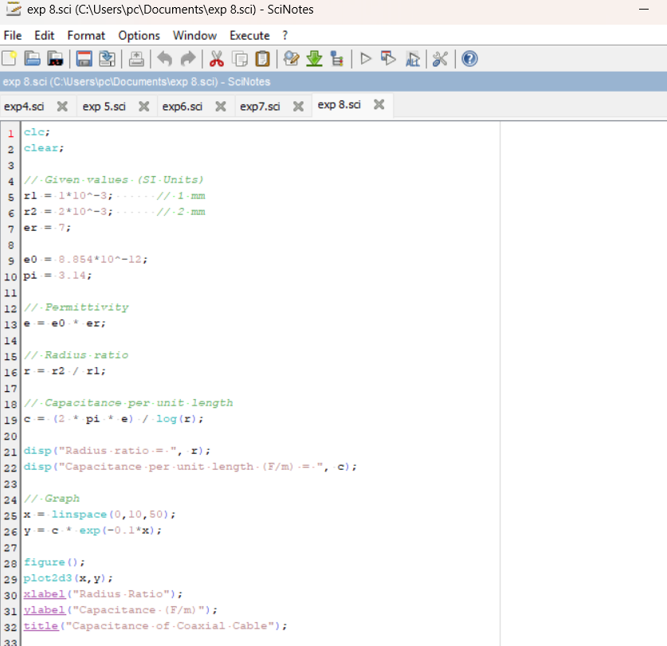
- Output:

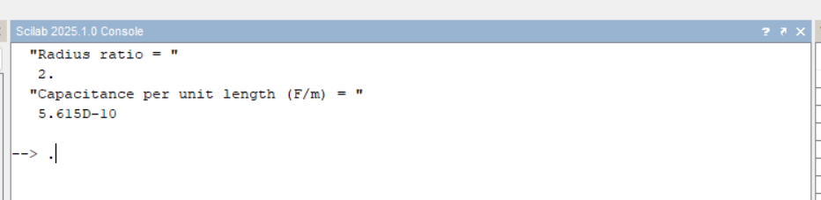

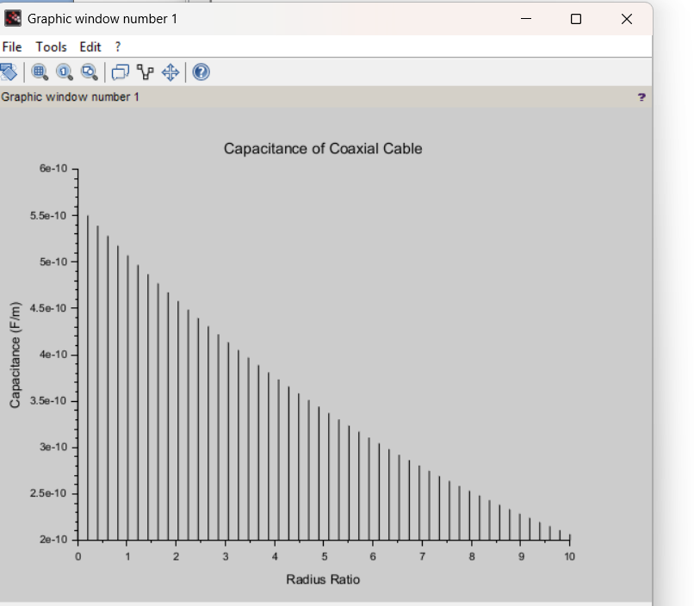

Calculation:
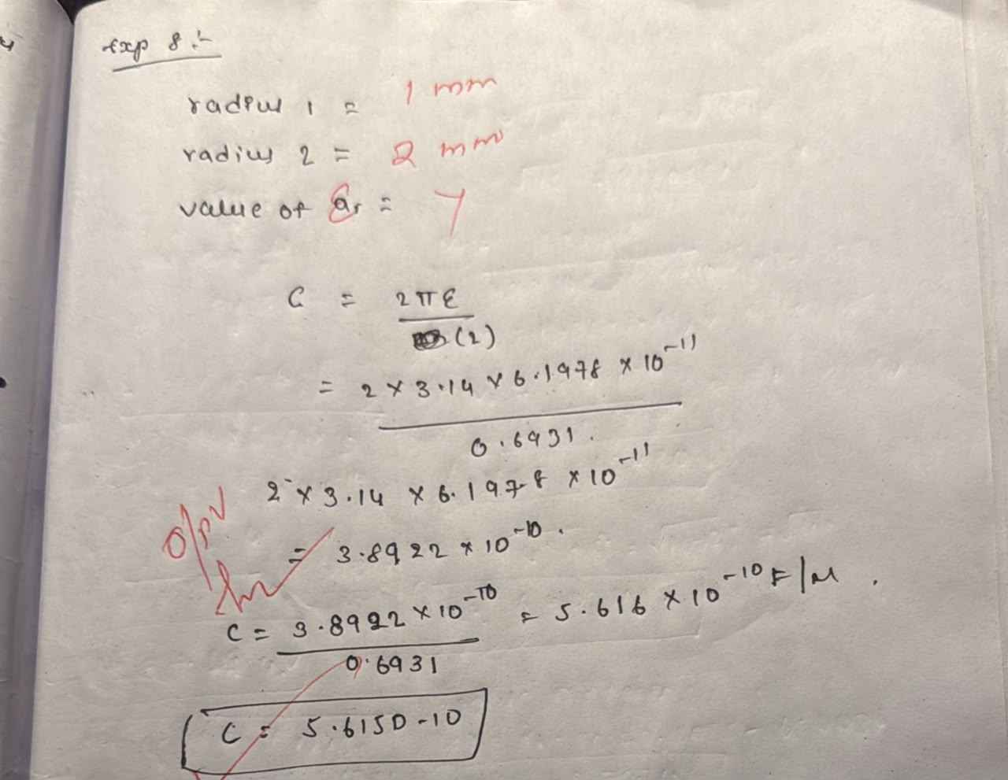

CASESTUDY1:Variation with Inner Radius

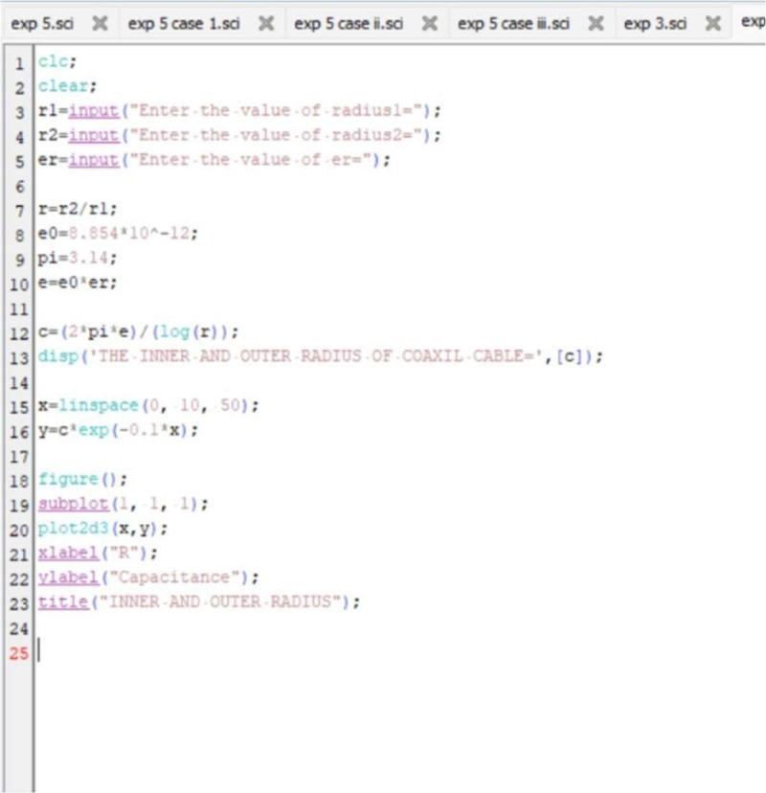

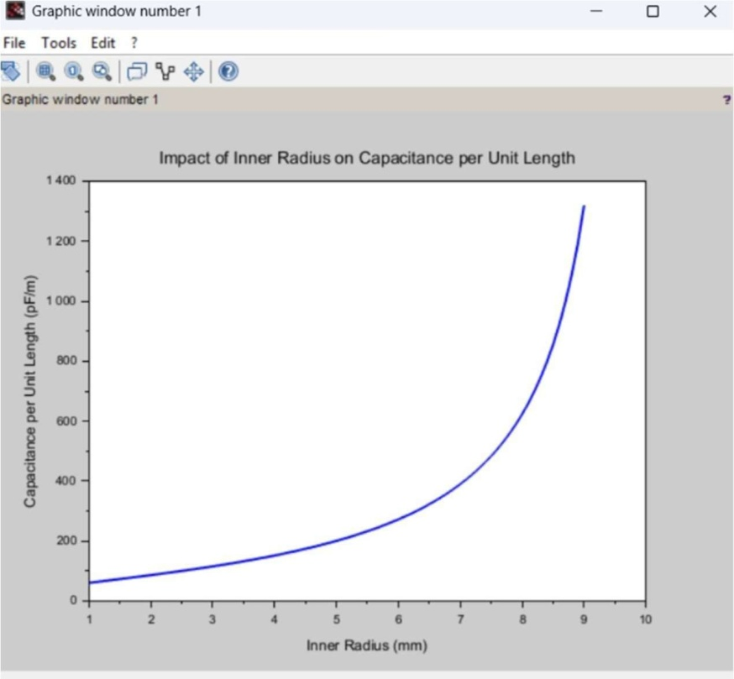

CASESTUDY2:VariationwithOuterRadius
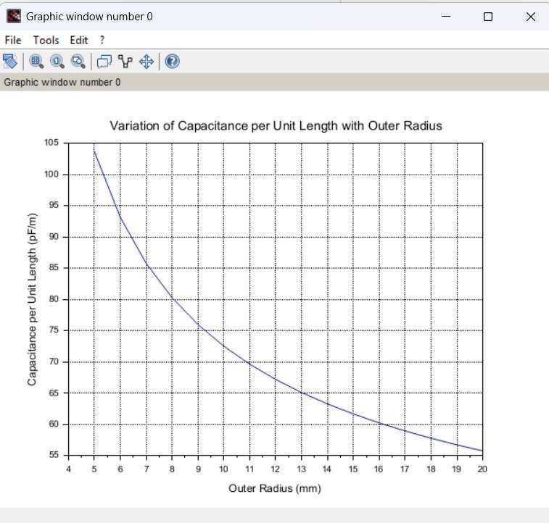

CASESTUDY3:VariationwithRelativePermittivity

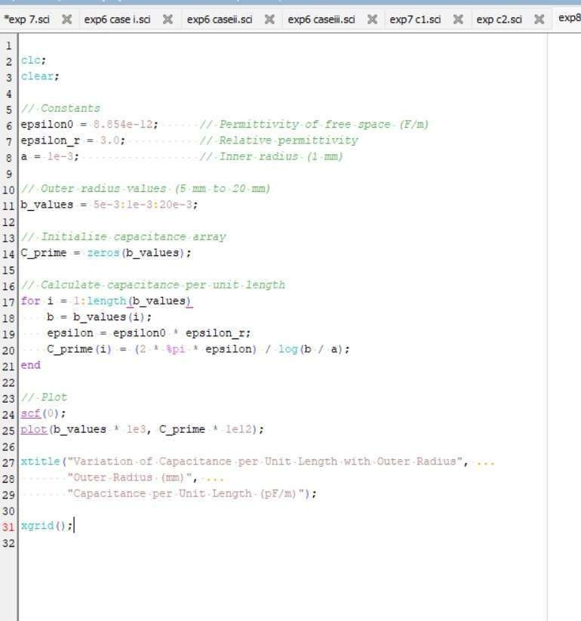

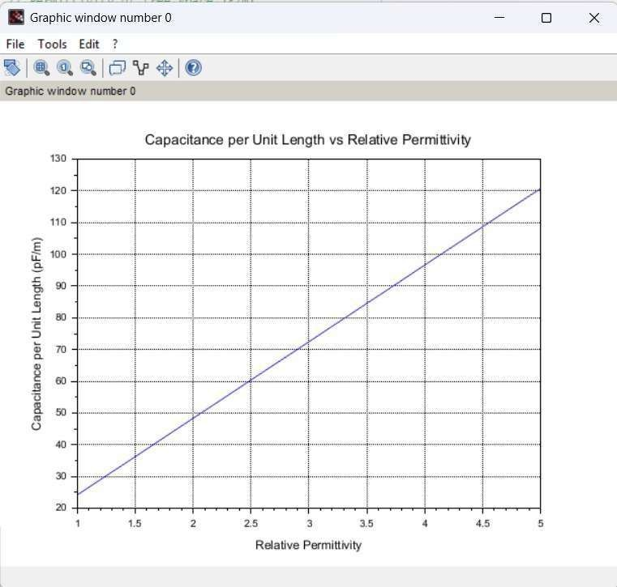

Result:ThustheprogramwasverifiedforCapacitanceofco-axialcableperunit length using SCILAB was successfully.

